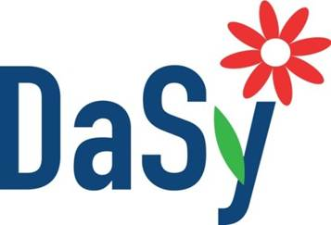
Stakeholder Engagement
Reflection Journal

Reflection is an essential part of the stakeholder engagement process, as well as a core part of learning. Use this journal to wrap up each session and reflect on the content and concepts presented. While prompts are provided to guide your thinking, you are invited to add thoughts and ideas that are most meaningful to you in your work and professional practice.

Session 2: Serving as a Stakeholder for a Cross-Agency Data System Initiative
Revisit key questions posed in the presentation to help you begin thinking about your role as a stakeholder in a collaborative data system initiative. Jot specific actions and additional questions you may have that are specific to your program(s).

Stage 1: Inform
Benefits of a High Quality Integrated Data System to Part C/619
How well do children enrolled in Part C/619 do when they enter kindergarten? Beyond kindergarten?
Is later school performance related to the length of time children are enrolled in the Part C/619 program or the age of referral?
What impact do the services we provide have on later school performance?
Needs and Interests
What questions does my program want to be able to answer that we are unable to answer now?
What data do we need to include in the new system to ensure we are able to answer the questions we want/need to answer?
How will my program’s involvement in the initiative be sustained?
What opportunities will I be given to participate in future enhancements to the system?
Other
What do I need to know about data systems to be a full contributor to discussions?
To whom can I speak to become more informed about data systems?

Stage 2: Prepare
What Part C/619 data should be included in the system?
What data from other programs/agencies need to be included for Part C/619 to be able to answer their critical questions?
What are my expectations for my engagement in the stakeholder process?
What are the expectations of others for my engagement?
How frequently do you expect to receive communications from the group’s leadership?
What is the timeline for my involvement?
What methods will be used to gather input from stakeholders?
How will decisions be communicated?
What are my expectations for my programs involvement in the collaborative data system initiative?
Stage 3: Act
Where is Part C/619 in the state’s priority timeline for including my program(s) data in the system? Will out data be included now or down the road?
What will Part C/619 to be able to do with the data in the system? What questions will we be able to answer?
Which program/agency “owns” and maintains the data?

Reflect
Is the work moving in the direction I hoped/expected?
How am I actively contributing to moving the work forward?
Am I getting the information I need from leadership to make informed contributions to discussions?

CHALLENGE QUESTION:

Given my role within the Part C or Part B 619 program, what are the benefits and challenges to participating as a stakeholder in a cross-agency data system initiative?

